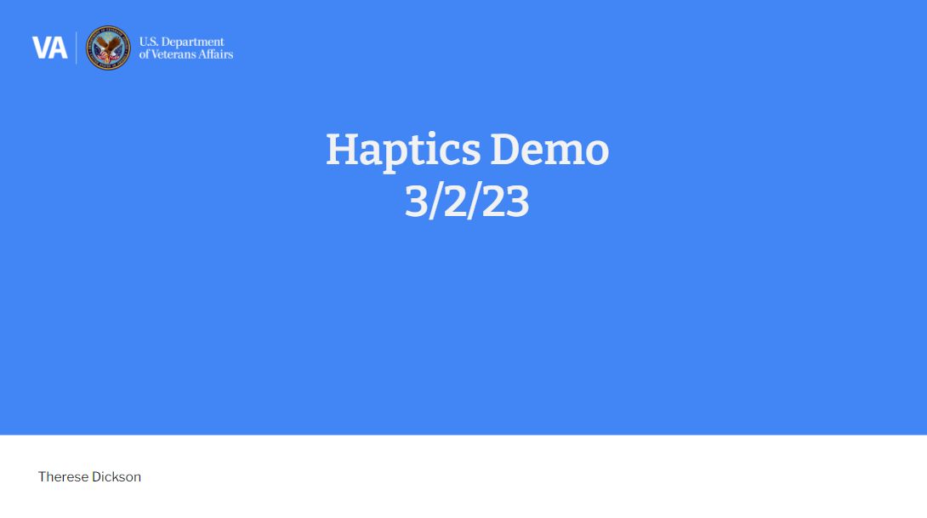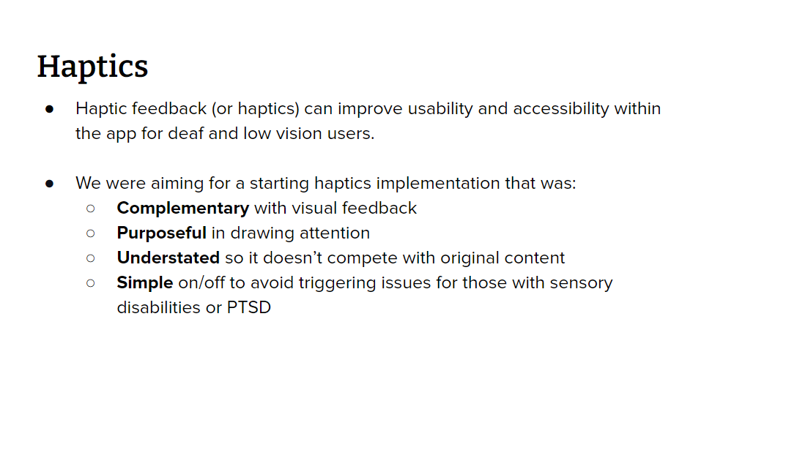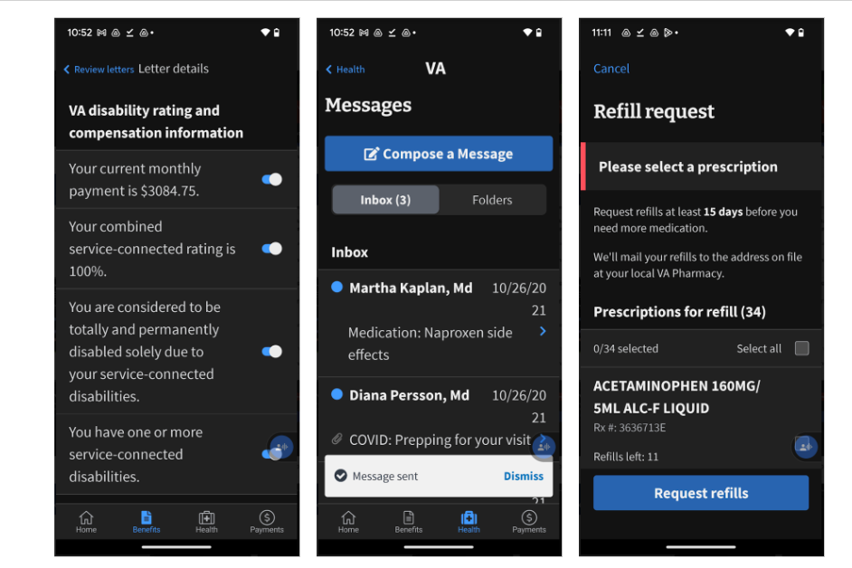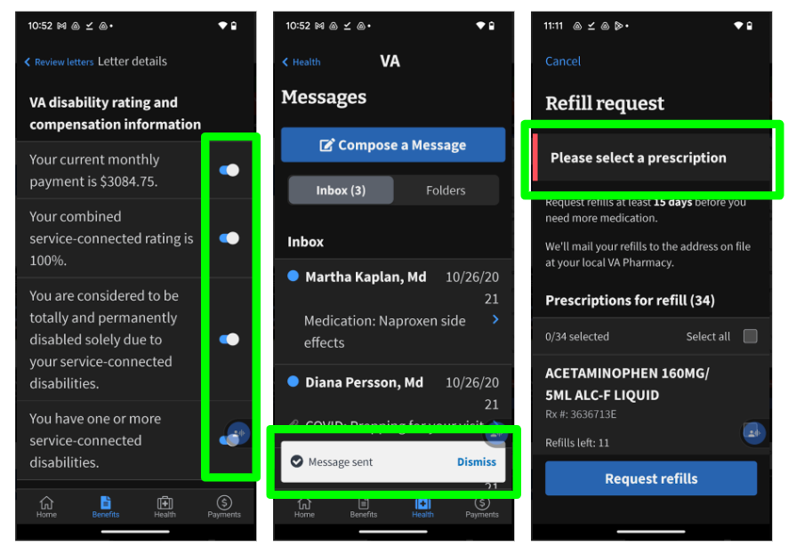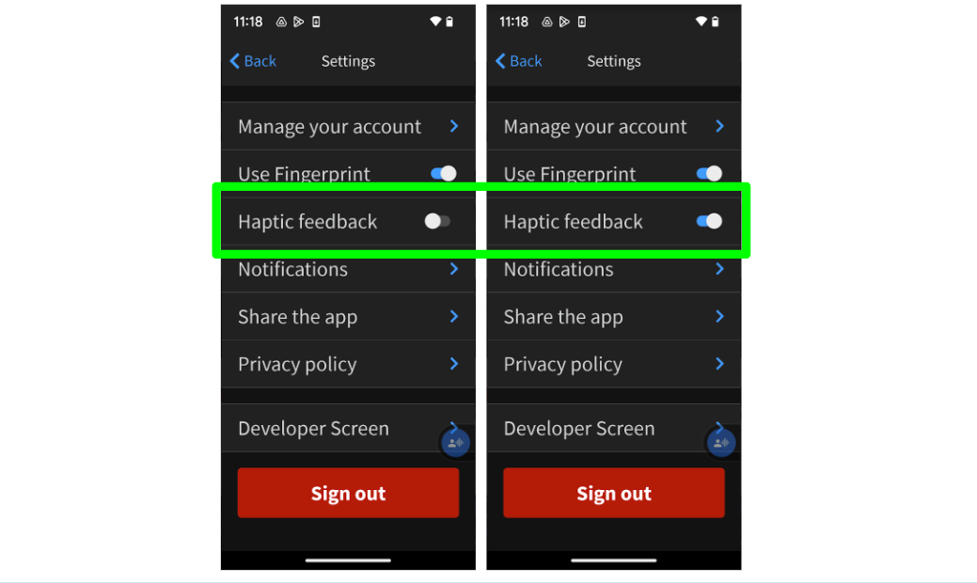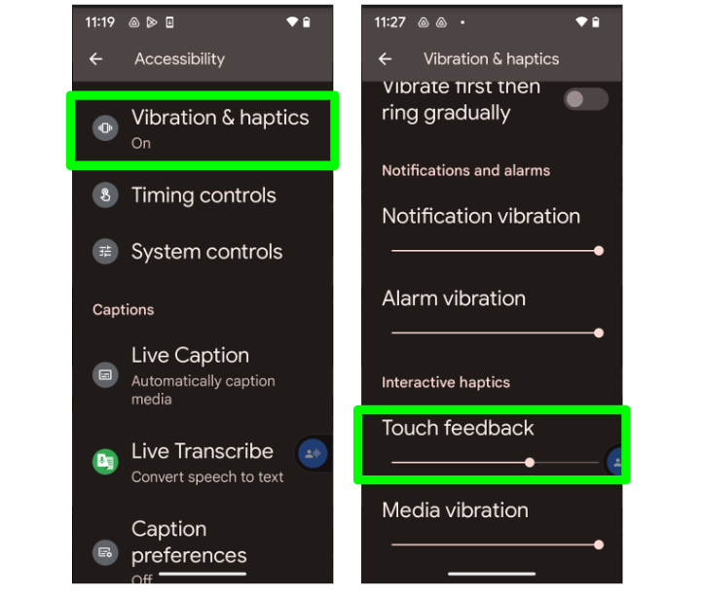

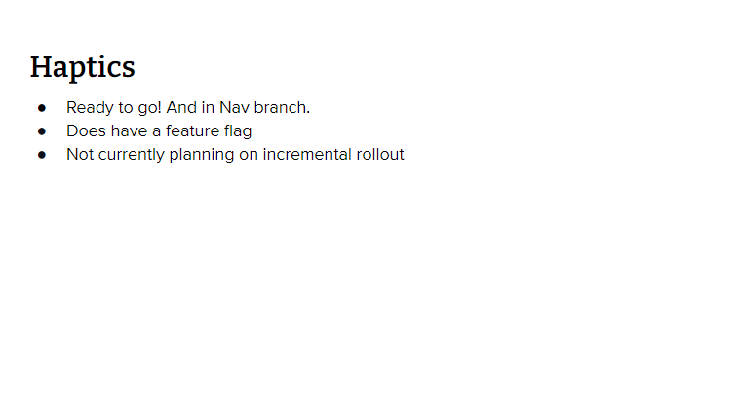

Notes:

* Research has shown that haptic technology intensifies the experience of immersion and immersive technology is known to increase user retention by 45%.
* The three components in the app that will have haptic feedback are
  + * Snackbars (components that appear to indicate success or failure of a user action, like sending a message – haptics will occur when the snackbar appears on the screen)
  + * Error alerts (alert boxes that draw attention to an error on a form submission, like forgetting to select a med to refill - haptics will occur when the alertbox appears on the screen)
  + Toggles
* These three were selected because they are in line with the **complementary** and **purposeful** goals, and - while I can’t demo it here! :) - we’ve picked haptic feedback patterns that are **understated** (another goal)
* **Complementary** with visual feedback
  + **Purposeful** in drawing attention
  + **Understated** so it doesn’t compete with original content
* defaulted to off, able to opt-in. Realized during implementation complexity/issues like “iPads don’t have haptic hardware, can/should we detect if using an iPad and hide the haptics toggle in the app” and other complex interactions between a distinct app setting, and the device software/hardware.
* Removed the in-app setting and are keying off of the device settings.
  + * Continues to support ‘simple’ - triggered by haptics generally, still OFF
  + * Reduces complexity/problems from original implementation plan
  + * Added bonus - devices like the google pixel here, with haptics settings more nuanced than on/off, can also get that information & provide consistent experience between VA app & ‘everything else on device’